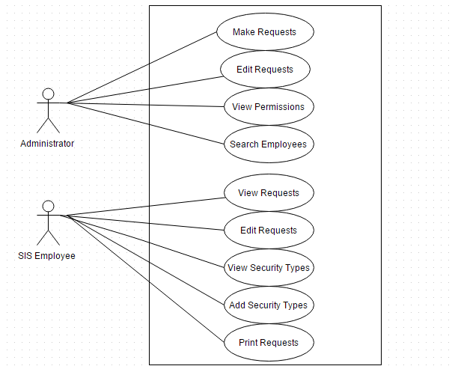

Shown above is the use case diagram for the system. As you can see each actor has different roles while interacting with the system. The diagram shows the respective accessibility to the available features in both cases.

